Harnessing Low-Temperature Geothermal Heat from Hot Oil Wells for Sustainable Fruit Drying in Iquitos, Peru: A Pathway to Economic Empowerment and Food Security

Jerjes Porlles1, Hugo Melgar3, Francis Cuestas2, Francisco Zegarra3, Rodolfo Torres3, Diana Pajuelo3, José González Tafur4

1 Department of Energy and Petroleum Engineering - University of North Dakota

2 Universidad Cientifica del Sur

3Thercal

4 Asociación de Profesionales Energias Renovables (APROENER)

**Keywords**

Low-temperature, geothermal heat, direct use, Peru

# ABSTRACT

This study examines the innovative use of low-temperature geothermal energy from hot oil wells in Iquitos, a remote city in the Peruvian Amazon, to power sustainable fruit drying systems, thereby contributing to local economic development and food security. Despite having abundant natural resources, local communities have limited access to sustainable technologies that can add value to their agricultural products. This study proposes a novel application of low-enthalpy geothermal energy—specifically, repurposing waste heat from existing or shut-in hot oil wells in the region—to power low-temperature fruit drying systems. The goal is to develop a decentralized, low-cost, and clean energy solution to preserve tropical fruits (aguaje, aguaymanto, lucuma, cocona, camu-camu, custard apple), including other non-local fruits.

Thermal energy from oil wells, typically in the 50–90°C range, is well-suited for convective fruit drying processes. Using thermodynamic modeling and site-specific data from legacy oil wells near the Loreto basin, we demonstrate that sufficient geothermal heat can be extracted without mechanical pumping, relying on natural convection or thermosiphon systems. A prototype indirect geothermal dryer was designed, integrating local materials and passive air circulation, optimized for low capital and maintenance costs.

Economic modeling suggests that a single fruit drying unit powered by geothermal heat can process up to 500 kg/day of fresh fruit, reducing post-harvest losses by up to 40% and increasing shelf life and marketability. Dried fruit products could be sold locally and regionally, creating new income streams for indigenous and rural communities. The proposed system can operate year-round and offers a reliable alternative to biomass or diesel-based dryers, significantly lowering carbon emissions.

This work highlights the untapped potential of hot oil wells as geothermal assets for direct-use applications in the Amazon. It proposes a scalable, community-based model that integrates renewable energy with rural development and food security goals. The project aims to attract investment and policy support to replicate similar systems across other tropical oil-producing regions with geothermal co-benefits.

## 1. Introduction

Access to sustainable and decentralized energy remains one of the significant challenges for rural and remote communities worldwide. In the Peruvian Amazon, particularly in the city of Iquitos, these challenges are exacerbated by the region’s geographic isolation, limited access to the national electricity grid, and high dependence on expensive and polluting diesel-based energy systems. Despite being surrounded by vast natural resources and agricultural potential, communities in this region continue to face energy poverty and significant post-harvest losses, limiting their ability to create value-added products and achieve food security. This study addresses these interlinked challenges through the novel application of low-temperature geothermal energy derived from hot oil wells for agricultural processing, specifically, fruit drying.

Iquitos, the largest city in the world inaccessible by road, relies heavily on river and air transport for the movement of goods and people. This remoteness translates into higher energy and transportation costs, limiting economic opportunities for its largely rural and indigenous population. One of the critical issues in the region is the post-harvest loss of highly perishable tropical fruits, such as bananas, papayas, mangoes, and pineapples, due to a lack of cold chains and preservation technologies (Guerra, 2022). While fruit drying presents a viable solution to extend shelf life and improve product marketability, traditional drying methods often rely on costly fuel sources, such as diesel, or involve inefficient and unhygienic sun-drying practices. These limitations underline the need for alternative, low-cost, and environmentally sustainable solutions adapted to the regional context. Iquitos is the capital of the Loreto Region and the largest city in the Peruvian Amazon (Cuesta et all, 2023). Located in northeastern Peru, it lies at the confluence of the Amazon, Nanay, and Itaya rivers (Figure 1). The city’s economy is largely based on trade, fishing, agriculture, forestry, ecotourism, and oil extraction, with a strong informal sector and limited industrial diversification. Agriculture in the surrounding rural areas focuses on subsistence crops and tropical fruits such as aguaje, aguaymanto, lucuma, bananas, papayas, pineapples, and camu-camu (Figure 2). However, due to logistical constraints and lack of cold chain infrastructure, much of this produce suffers from post-harvest losses, limiting its commercial value (Ruiz, 2022).

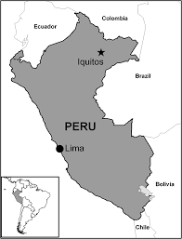

Figure 1: Location of Iquitos - Peru

Despite being located in a resource-rich region, Iquitos suffers from limited access to energy and high electricity costs. The city is not connected to Peru’s national electrical grid (SEIN) due to its geographical isolation, surrounded by dense jungle and accessible only by air or river (Ambikapathi, 2021). As a result, Iquitos relies heavily on diesel-powered thermal plants operated by Electro Oriente, the regional utility. Diesel fuel is transported over long distances, often by barge, resulting in high generation costs and carbon emissions. According to official data from the Ministry of Energy and Mines (MINEM), electricity tariffs in Iquitos are significantly higher than the national average due to these logistical costs and dependency on imported fuel. In addition to diesel, small-scale biomass is used in peri-urban and rural areas for cooking and limited heating applications. However, it often leads to indoor air pollution and deforestation (Swierk, 2014). There have been pilot projects to introduce solar PV systems in isolated communities, but these efforts remain limited in scale and often lack long-term maintenance support (Mucha, 1980).

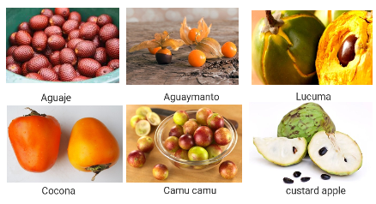

Figure 2: Local fruit, Iquitos – Peru (Promperu, 2020)

2. Geothermal Resource Assessment

The region host untapped geothermal potential, particularly in the form of residual heat from shut-in or low-productivity oil wells. The Loreto Basin, which surrounds Iquitos, has undergone decades of hydrocarbon development, leaving behind thermal wells with subsurface fluids at temperatures ranging from 50 to 90°C. While these temperatures are insufficient for electricity generation, they are well-suited for direct-use applications such as convective drying, water heating, and industrial thermal processes.

Given the convergence of abundant geothermal heat, agricultural waste, and high diesel prices, Iquitos presents an ideal setting for demonstrating how low-enthalpy geothermal resources can support local economies. Repurposing waste heat from oil wells not only reduces dependence on diesel but also empowers local agricultural producers by enabling the value-added processing of fruits and crops in regions where conventional energy alternatives are expensive or unreliable.

Co-produced water in huge volumes is a significant problem for oil and gas producers, as it requires disposal or reinjection into reservoirs through injection or disposal wells, a costly process that reduces the producers' net profit. However, the hot temperature of co-produced water can be harnessed to generate electricity through the geothermal binary cycle. The application of geothermal binary cycle technology to an abandoned oil field or one with a high water cut (close to depletion) is opportune for generating electricity, leveraging the existing infrastructure and facilities built in the oil field, both underground (in wells) and on the surface.

Hydrocarbons and geothermal energy are two types of energy resources that coexist in the sedimentary basins of the Peruvian rainforest. In the Peruvian jungle, there are hundreds of unprofitable, abandoned wells and several oil fields that produce with high water cuts (over 95%), indicating that the oil fields are close to depletion. At the same time, the average temperature of the fluids extracted at the wellhead is 100°C. Furthermore, it is observed that the oil fields in the Peruvian jungle already have the infrastructure, production and injection wells, to harness them and adapt them to a binary-cycle geothermal system, offering the possibility of providing electricity to communities located in remote locations.

2.1Oil fields in the Peruvian jungle

This research proposes repurposing an underutilized and largely overlooked energy source—waste heat from existing or shut-in oil wells—as a form of direct-use geothermal energy. Oil wells, particularly in mature hydrocarbon fields like those near the Loreto Basin, often produce thermal fluids with temperatures in the 50–90°C range even after they cease to be economically viable for oil extraction (Figure 3). Instead of being abandoned, these wells can be transformed into assets for community development by harnessing their residual thermal energy for low-enthalpy applications, such as convective fruit drying (Melgar, 2020).

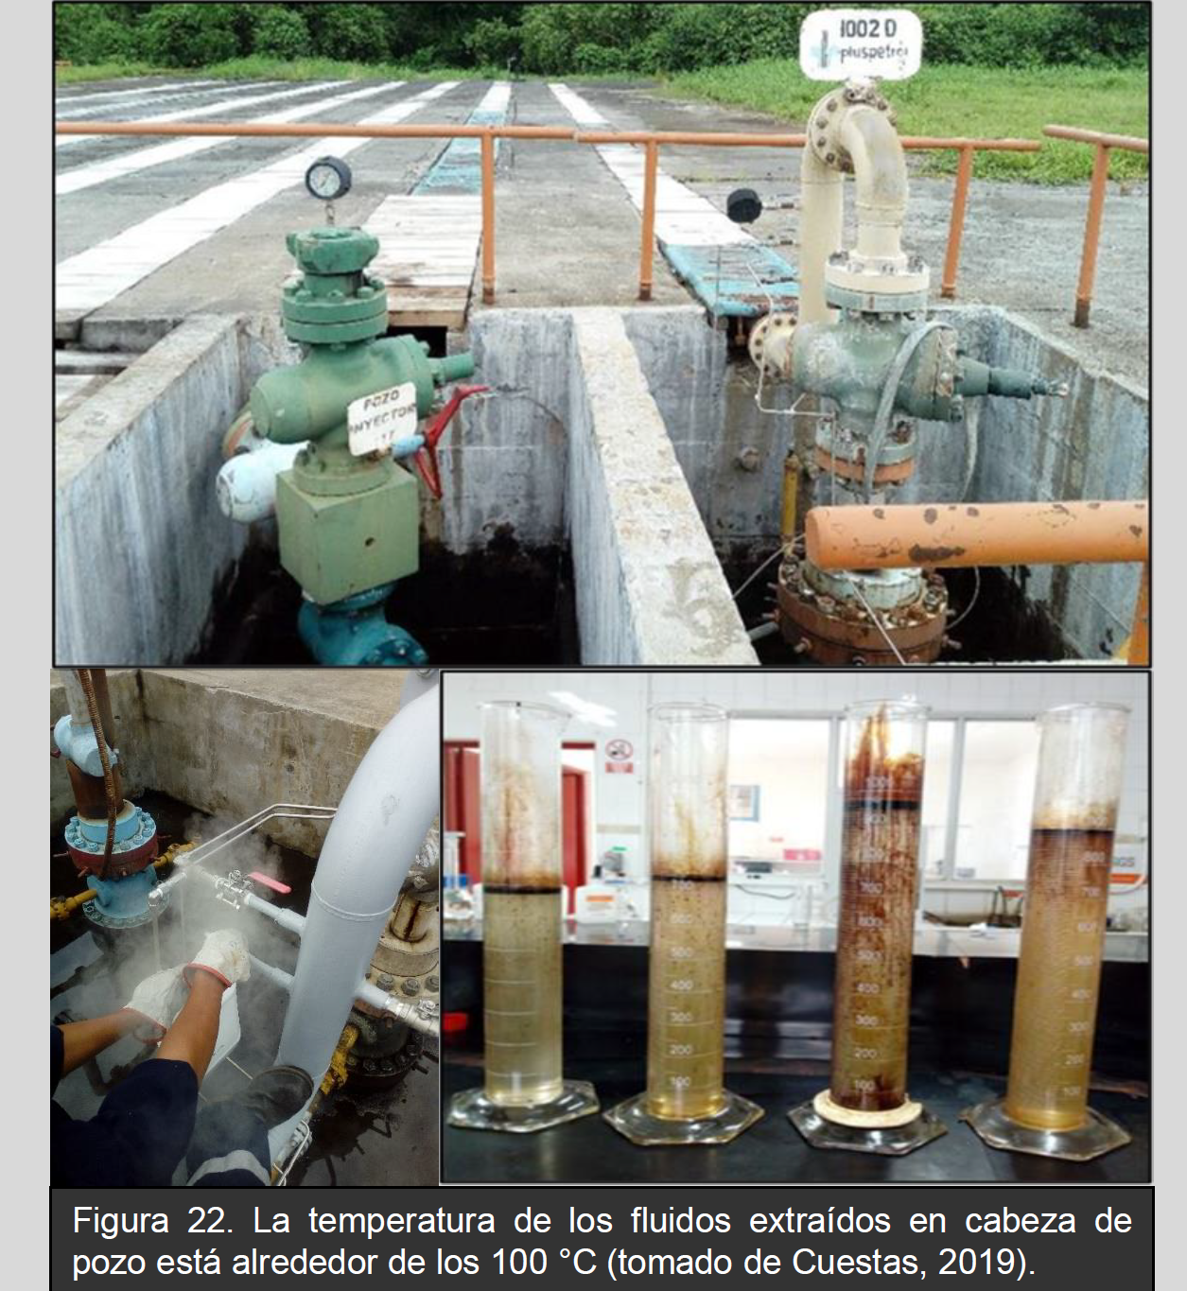

Figure 3 Wellheat and fluid of the wells, Iquitos – Peru (Cuesta, 2019)

The concept of low-temperature geothermal energy is not new; however, its integration with agricultural value chains in isolated tropical regions remains largely unexplored. This study introduces a novel decentralized energy model in which abandoned or idle oil wells serve as heat sources for small-scale, indirect geothermal dryers designed with local materials and adapted to regional climatic and social conditions (Eagle-Bluestone, 2021). The system is based on passive heat transfer mechanisms, such as natural convection or thermosiphons, eliminating the need for complex and maintenance-intensive pumping systems. This not only makes the technology more accessible and cost-effective but also ensures long-term viability in resource-constrained settings.

Thermodynamic modeling was employed to assess the heat exchange capacity of selected wells and to estimate the energy requirements for fruit drying processes. These models, combined with site-specific data, informed the design of a prototype dryer that maximizes thermal efficiency while minimizing energy loss. The system features insulated drying chambers, heat exchangers, and air circulation mechanisms that maintain consistent drying temperatures while preserving fruit quality.

Economic analysis suggests that a single drying unit powered by geothermal heat can process up to 500 kg of fresh fruit per day, resulting in a reduction of post-harvest losses by up to 40%. This capacity not only ensures local food preservation but also opens opportunities for community-level entrepreneurship and participation in regional dried fruit markets. The use of geothermal energy also significantly reduces greenhouse gas emissions compared to diesel-based alternatives, aligning with broader climate mitigation goals and Peru’s commitments under the Paris Agreement.

The reservoirs from which hydrocarbons are extracted in the Peruvian jungle are located approximately 3.5 km deep with an average temperature of 257°F (125°C), slightly higher than the normal geothermal gradient (30°C/km). This is because oil deposits are located near the crystalline basement that is in contact with the Earth's internal magma, which is a heat conductor towards the Earth's crust (Figure 4).

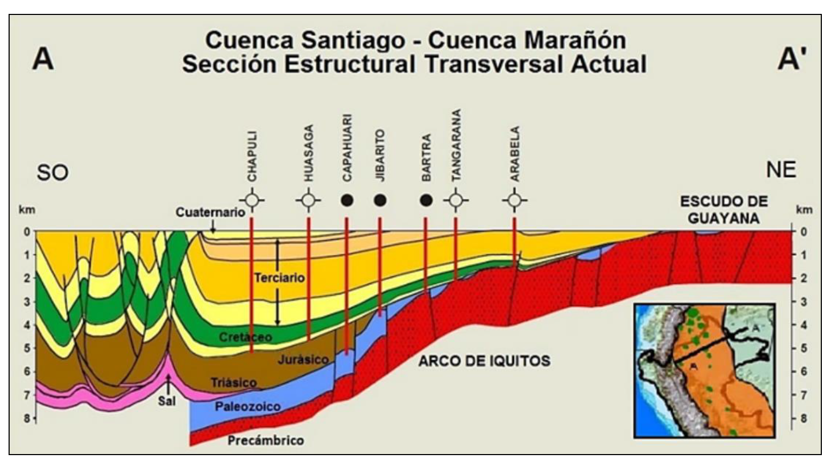

Figure. 4 Foreland basin system model for the Santiago and Marañón basin (Source: Perupetro)).

On the other hand, it is known that over the last decade, oil production in the Peruvian rainforest has been declining, accompanied by an increase in water production (Figure 5). To illustrate this, we will mention two oil blocks in the Peruvian rainforest that have high geothermal potential to be exploited.

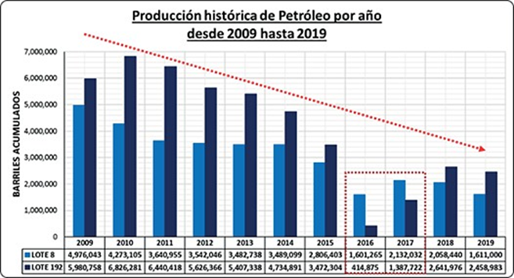

Figure. 5 Depletion of oil production in Block 8 and Block 192 (Source: Perúpetro)

Block 192 (formerly Block 1AB), the average temperature of the injected co-produced water is 184°F (84.4°C), measured at the injection wellhead. These temperatures are lower than those at the head of the producing well, which register around 100°C, because the extracted fluids travel through the production lines to the separators in the batteries. This oil field has a water cut of 95%.

In Block 8, the temperature of the fluids extracted at the wellhead is close to 100°C. This oil field produces more than 400,000 barrels (64,000 m3) of water per day. The volumes of hot water co-produced in these fields are injected into reservoirs with an average temperature of 82°C. This oil field has a water cut of 98%. For the reasons explained above, the oil fields in Block 8 are suitable for exploitation and electricity generation through the implementation of binary cycle technology, especially the Corrientes-Battery 1 oil field. This oil field produces enormous volumes of hot water along with oil, with an average water cut of 98%, which is injected into the reservoirs through injection and disposal wells. The temperature of the fluids extracted at the wellhead in Battery 1 is around 100 °C. Over time, this field can be converted into a geothermal field and utilized directly for geothermal energy.

3. Project description analysis

Iquitos, the largest city in the Peruvian Amazon, faces a severe food security crisis rooted in geographic isolation, economic hardship, and environmental factors. Surrounded by rivers and accessible only by boat or plane, the city’s food supply is closely tied to river transport and seasonal cycles [(](https://www.cambridge.org/core/journals/public-health-nutrition/article/la-nina-weather-impacts-dietary-patterns-and-dietary-diversity-among-children-in-the-peruvian-amazon/D5DCC0D2D3FD1E1858C73F9930C611DD?utm_source=chatgpt.com)Ambikapathi, 2021). A 2015 survey revealed that local families in Iquitos subsist on about US$0.85 per person per day, often purchasing staples on credit and relying on fishing and foraging during lean periods. According to national data, over 50% of Peru’s population—and as many as 70% of those in Amazonian areas—face moderate to severe food insecurity. In Loreto, the region encompassing Iquitos, up to 46% of children under five suffer from anemia and chronic malnutrition [(Swierk , 2014)](https://www.researchgate.net/publication/279048137_Environmental_Perceptions_and_Resource_use_in_Rural_Communities_of_the_Peruvian_Amazon_Iquitos_and_Vicinity_Maynas_Province?utm_source=chatgpt.com). Contributing factors include high food prices—fruits and vegetables are often unaffordable—unreliable river transport, and limited dietary diversity. These compounding issues underscore the urgent need for targeted interventions to strengthen food access, nutrition, and resilience in Iquitos.

According to Marca Perú, high-value fruits grown in this region include lucuma, cherimoya, camu camu, pitahaya (dragon fruit), açaí, and rambutan—all noted for their antioxidant and nutritional qualities. Among these, açaí is already being sustainably harvested by local communities near Iquitos, providing a reliable income and reducing pressure on deforestation.

The region’s fruit cultivation potential is further supported by agroforestry projects in Loreto, where farmers successfully integrate species like uvilla and pijuayo into productive plots with favorable carbon sequestration characteristics. Additionally, Iquitos markets regularly feature over 50 wild-harvested fruit species—such as camu camu—critical to the local economy, though many face depletion risks without sustainable management. Table 1 presents the types of fruits, their nutritional properties, uses, and export potential.

**Table 1. Fruits, nutritional properties, type of use, and export potential.**

|  |  |  |  |  |
| --- | --- | --- | --- | --- |
| **Fruit** | **Nutritional/Medicinal Properties** | **Typical Use** | **Export Potential** | **Challenges** |
| Aguaje | Rich in beta-carotene (Vitamin A), Vitamin C, phytoestrogens, and antioxidants | Consumed fresh, in juices, ice cream | Moderate – niche markets in cosmetics and health food | Perishability, need for cold chain logistics |
| Aguaymanto | High in Vitamin C, Vitamin A, and antioxidants; supports immune system | Dried, fresh, in jams and desserts | High – already exported from Peru as “Goldenberry” | Requires careful harvesting and drying for export |
| Lúcuma | High in fiber, beta-carotene, and iron; low glycemic index | Powdered form, ice cream, smoothies | High – exported as powder for superfood markets | Processing infrastructure required |
| Cocona | Rich in Vitamin C and polyphenols; used for reducing cholesterol | Fresh, in juices, sauces | Low – mainly consumed locally | High perishability, less awareness internationally |
| Camu Camu | Exceptionally high in Vitamin C (up to 60x more than orange), antioxidant-rich | Juice, dietary supplements | High – growing demand in nutraceutical markets | Transport logistics, harvesting seasonality |
| Chirimoya | Rich in Vitamins B and C, fiber; known for its creamy texture and anti-inflammatory properties | Eaten fresh, in smoothies and desserts | Moderate – exported regionally | Delicate fruit; sensitive to bruising |

Table 2 summarizes key fruits produced and sold in Iquitos, Peru. Aguaje is a staple superfruit, but it is threatened by destructive harvesting practices, which result in steep seasonal price swings (approximately $ 3–$ 24 USD per sack). Camu camu is rich in vitamin C and is traded locally and internationally, although its market faces volatility due to perishability, export logistics, and certification requirements. Arazá, ungurahui, and carambola are emerging products with niche markets, valued for their nutrients and flavors, but face challenges in storage and market reach. The artisanal fruit economy in Iquitos supports rural incomes and unique biodiversity; however, limited infrastructure, seasonal fluctuations, and unsustainable harvesting practices constrain its growth.

Currently, the Peruvian Organic Law on Geothermal Resources (Law No. 26848) establishes the comprehensive legal framework for the exploration, development, and sustainable use of geothermal energy in Peru. It defines the procedures for obtaining authorizations and concessions, outlines the rights and obligations of geothermal operators, and regulates the coexistence of geothermal activities with other land uses. The law sets clear guidelines for administrative jurisdiction, establishes conditions for the expiration of geothermal rights, and aims to provide legal certainty for investors while ensuring the responsible and efficient utilization of the country’s geothermal resources. This legislation plays a crucial role in promoting Peru’s transition to renewable energy, supporting sustainable economic development.

**Table 2. Fruits, main production sites, approx. cost.**

|  |  |  |  |
| --- | --- | --- | --- |
| **Fruit** | **Main Production Sites / Season** | **Approx. Cost (local market)** | **Key Challenges** |
| Aguaje | [Abundant in Loreto; Aug–Dec (reddit.com)](https://www.reddit.com/r/PERU/comments/r1b32h?utm_source=chatgpt.com) | Sacks ~10–90 PEN (~3–24 USD) | Destructive harvesting (tree felling), seasonality, overharvest |
| Camu Camu | Floodplains of Loreto, Ucayali; Nov–Mar | Often sold as juice or powder; value chains add cost | Perishability, export volatility, certification/logistics issues |
| Arazá | Wild/cultivated in Amazon; year-round | Prices vary; niche export potential | Short shelf-life (~72 h), limited market infrastructure |
| Ungurahui | Harvested locally; year-round | Typically sold as fresh juice; premium owing to nutrients | Limited distribution channels; preservation/storage limits |
| Carambola | Grown in Amazon region; year-round | Juice beverages in markets; modest pricing | Acidic taste limits appeal; seasonal gluts can depress prices |

To address post-harvest losses and improve food security in the Loreto region, we propose a sustainable fruit drying project in Iquitos, Peru, focusing on locally abundant Amazonian fruits such as aguaje, camu camu, ungurahui, and arazá. Due to their high moisture content and short shelf life, many of these fruits spoil quickly under the region’s humid tropical conditions. The lack of cold storage and efficient transport infrastructure compounds this problem, resulting in significant economic losses for local farmers and vendors. By introducing low-temperature drying technologies powered by renewable energy sources—such as solar or geothermal heat from nearby oil wells—we can extend the shelf life of these fruits, enabling year-round availability, reducing food waste, and unlocking new markets for dried and powdered fruit products (Figure 6)

The project will involve the construction of a small-scale modular drying facility near key production areas. Training programs will be offered to local producers and cooperatives on fruit preparation, drying protocols, hygiene standards, and value chain integration. Dried fruits and powders (e.g., camu camu for supplements or aguaje as natural colorants) will be marketed to regional and national buyers, with the potential for international export. This initiative aligns with Peru's goals for rural economic empowerment, biodiversity conservation, and sustainable agriculture. Moreover, by creating new income streams through fruit processing, the project will reduce pressure on natural resources, support women entrepreneurs often engaged in fruit collection, and strengthen food resilience in the Amazon basin.

The food drying sector depends on sophisticated drying technologies that deliver precise moisture management, ensuring both food safety and product quality. Critical performance features include precise temperature regulation, the use of clean heat sources such as steam, electricity, or heat pumps, and high energy efficiency. Modern food dryers are designed with consistent heat systems, powerful circulation fans, excellent insulation, and energy efficiencies exceeding 90%.

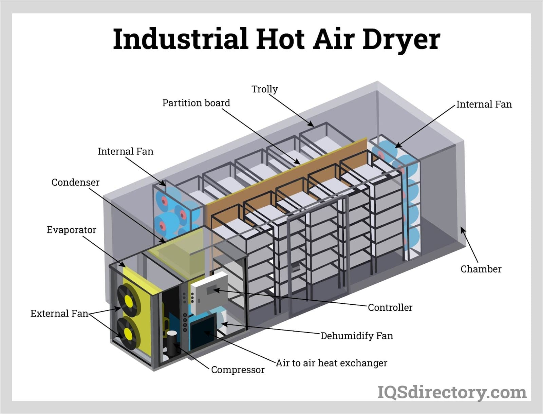

Figure. 6: Typical Industrial Air Dryer for the project

Common food dryer types include multi-layer mesh belt continuous dryers, well-suited for high-volume processing of fruits, vegetables, grains, and herbs, and heat pump dryers, which utilize refrigerant-based cycles for gentle, automated drying. Mesh belt dryers offer excellent airflow and customizable air patterns, making them ideal for products sensitive to temperature fluctuations. In contrast, heat pump dryers maintain lower temperatures to prevent oxidation, nutrient loss, or microbial growth when drying items such as seafood, bacon, fruits, or leaves. Advancements such as programmable logic controllers (PLCs), automated feeding and discharge systems, and real-time humidity control have significantly improved accuracy and reliability, cementing these technologies as essential tools in industrial-scale food processing and preservation.

Table 3 describing the key characteristics of a typical industrial hot air dryer, which would be suitable for a local fruit-drying project in Iquitos, Peru: This table synthesizes the technical and functional aspects from your detailed source material, emphasizing how an industrial hot air dryer meets the requirements of high-quality, efficient, and scalable food drying.

**Table 3. Fruits, main production sites, approx. Cost.**

|  |  |
| --- | --- |
| **Characteristic** | **Description** |
| Drying Method | Convective (direct) heat transfer; uses hot air circulated around the product for efficient and uniform drying. |
| Heat Source | Electric heaters, steam coils, or heat pumps producing clean, stable hot air; suitable for food-grade applications. |
| Temperature Range | Adjustable; typically operates between 40–90°C, allowing gentle drying of heat-sensitive products like fruits to preserve nutrients and color. |
| Airflow System | Equipped with robust circulating fans that provide uniform hot air distribution across all layers of the drying chamber or conveyor system. |
| Control Features | Integrated programmable logic controllers (PLCs) for precise temperature, time, and humidity regulation; automatic feeding and discharge can be included. |
| Energy Efficiency | Designed with high insulation and optimized airflow; energy efficiency often exceeds 85%, minimizing operational costs. |
| Capacity | Scalable; small to large industrial dryers can process from a few kilograms to several tons of fresh fruit per hour, ideal for varying production needs. |
| Moisture Control | Capable of real-time humidity monitoring and control, ensuring target moisture content is consistently achieved for food safety and shelf stability. |
| Construction | Stainless steel drying chambers and food-safe components to ensure hygiene; easy-to-clean surfaces to comply with food processing standards. |
| Applications | Ideal for fruits (e.g., camu camu, aguaje, cocona), vegetables, herbs, and other agricultural products; also used in pharmaceuticals, chemicals, and textiles. |
| Benefits | Inhibits microbial growth, extends shelf life, reduces food waste, and adds value by enabling local farmers to produce export-ready dried fruit products. |

3. Procedure description analysis

Drying fruits in Iquitos, Peru, offers significant socio-economic benefits for the local population. First, it addresses the region’s high post-harvest loss due to limited infrastructure and perishability of tropical fruits like camu camu, cocona, and aguaje. By transforming fresh produce into value-added dried products, farmers and cooperatives can extend the shelf life of their harvests, stabilize income throughout the year, and access broader markets, including national and international ones. This value chain diversification fosters economic resilience and empowers smallholder farmers with new revenue streams.

Second, the initiative promotes food security and community well-being. Dried fruits provide a nutritious, locally sourced alternative to processed snacks, improving diets in both urban and rural areas. Additionally, the establishment of local drying facilities—powered by solar or geothermal heat—encourages local employment, technical skill development, and entrepreneurship. The integration of sustainable drying technology not only supports environmental goals but also reduces food waste. These collective benefits make fruit drying a strategic tool for rural development in the Amazon region. Figure 7 describes the diagram of the fruit drying workflow, including harvesting, sorting, drying, packaging, and distribution.

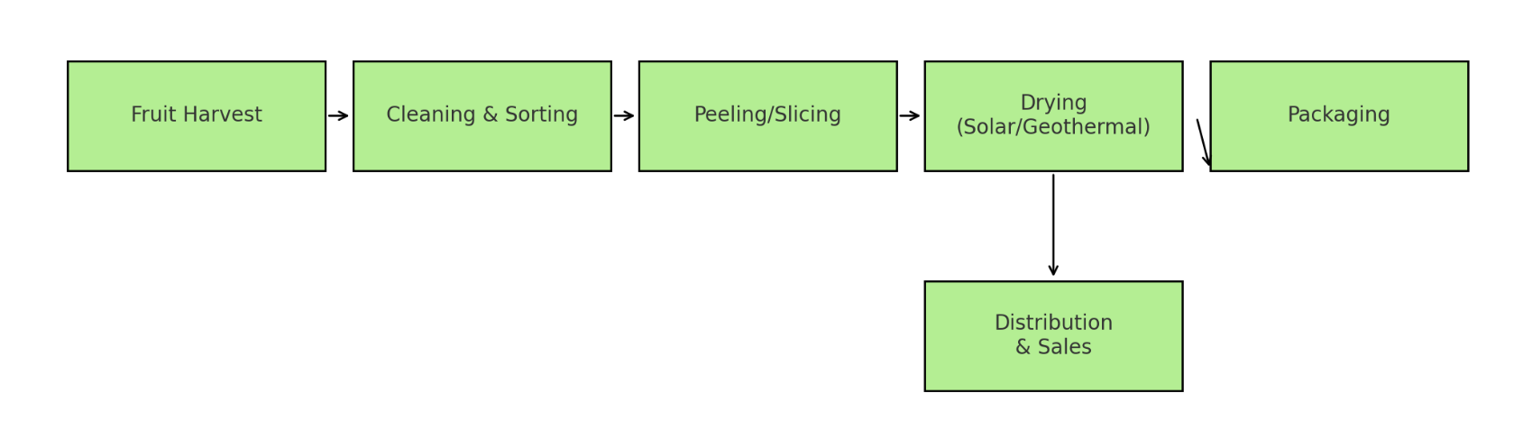

Figure. 7 Diagram of the fruit drying workflow, including harvesting, sorting, drying, packaging, and distribution

Implementing a local fruit drying project in Iquitos requires evaluating both capital and operational costs, as well as estimating long-term benefits to determine its Net Present Value (NPV). Capital expenditures (CapEx) include the purchase of drying equipment (solar or geothermal-powered), construction of basic infrastructure, packaging units, and initial training programs. Based on similar rural development projects in Peru and Latin America, the total initial investment for a small-scale facility (processing ~500 kg/day) may range from US$25,000 to US$40,000. Operational expenditures (OpEx) such as labor, maintenance, energy (if non-solar), logistics, and fruit sourcing would amount to approximately US$7,000 to US$10,000 annually. Assuming average revenues of US$2.5 per kg of dried fruit and selling ~40 tons annually, annual income could reach US$100,000, with gross profits of ~US$60,000 per year after costs.

3. Project description analysis

Using a conservative discount rate of 10% and a project lifespan of 10 years, the NPV calculation indicates the project would be financially viable. For example, if the initial investment is US$30,000 and the annual net profit is US$60,000, the project’s NPV exceeds US$370,000, signaling high profitability. Furthermore, the project can generate community-level benefits, including job creation (5–8 direct jobs and numerous indirect), improved food security, and reduced post-harvest losses. If scaled, the initiative could act as a cooperative model, integrating multiple farmer groups and boosting regional development. Table 4 describes the economic parameters

|  |  |
| --- | --- |
| **Category** | **Value** |
| Initial Investment (CapEx) | US$25,000 – US$40,000 |
| Annual Operating Cost (OpEx) | US$7,000 – US$10,000 |
| Annual Revenue | ~US$100,000 |
| Annual Net Profit | ~US$60,000 |
| Project Duration | 10 years |
| Discount Rate | 0.1 |
| Net Present Value (NPV) | ~US$370,000 |
| Direct Jobs Created | 5–8 |
| Break-even Period | < 1 year |

3. Results and Discussion

* This study demonstrates that harnessing low-temperature geothermal heat from hot oil wells in Iquitos offers a viable, sustainable pathway to address post-harvest losses, reduce dependence on diesel, and add value to local agricultural production. By repurposing existing thermal energy from shut-in or low-productivity oil wells, communities can implement decentralized fruit drying systems that operate year-round with minimal operating costs and significantly lower carbon emissions. The proposed geothermal dryers can reduce post-harvest fruit losses by up to 40%, extending shelf life and opening new market opportunities for dried fruit products. Moreover, the integration of passive air circulation and locally sourced materials ensures affordability and adaptability to rural Amazonian conditions, making this technology accessible to indigenous and smallholder farmers.
* Furthermore, the project highlights an untapped synergy between hydrocarbon legacy infrastructure and renewable geothermal direct-use applications in the Loreto Basin. It establishes a replicable model of community-based energy transition that can be scaled to other tropical oil-producing regions with similar geothermal co-benefits. Beyond economic benefits, the initiative contributes to food security, local empowerment, and reduced pressure on deforestation by displacing biomass use. Ultimately, this innovative approach illustrates how geothermal resources, often overlooked in tropical regions, can support integrated rural development strategies, attract investment, and inform policy frameworks aimed at fostering sustainable and inclusive economic growth in Peru’s Amazon.
* Given Iquitos’ unique convergence of abundant geothermal heat, high diesel prices, and substantial agricultural potential, the region offers a promising opportunity to demonstrate how low-temperature geothermal resources can support local economies through sustainable energy solutions. Repurposing residual heat from shut-in or mature oil wells provides a decentralized and reliable energy source for agricultural processing, specifically fruit drying, which can reduce post-harvest losses and create new value-added products for local and regional markets. Thermodynamic assessments of wells near the Loreto Basin confirm that fluid temperatures in the range of 50–100°C are well-suited for convective drying applications, enabling year-round operation without the need for diesel fuel or complex infrastructure. By designing dryers optimized for local conditions and passive heat transfer, communities can benefit from accessible, low-cost, and environmentally friendly technology that turns a waste byproduct into a driver of economic resilience and food security.
* Moreover, high water cut oil fields in the Peruvian Amazon—like Blocks 8 and 192—produce enormous volumes of hot co-produced water, which poses a disposal challenge but also represents an untapped geothermal energy resource. These fluids, with temperatures near 100°C, can be harnessed through binary cycle technology or direct-use systems to provide electricity or thermal energy for communities isolated from the national grid. By integrating geothermal heat with local agricultural processing, the project not only reduces greenhouse gas emissions and operational costs but also creates entrepreneurial opportunities in fruit drying, boosting household incomes and market participation. Such initiatives support long-term food security and nutrition in Iquitos, where limited transport, high food prices, and widespread poverty exacerbate malnutrition and economic vulnerability.

Acknowledgement

Thank you to the reviewers for their constructive comments and team member contributions that made this paper better.

##### REFERENCES

Barson. D. (2002). Marañon Basin Petroleum Hydrogeology Study. Perupetro and Canadian Petroleum Institute. Obtenido de: https://www.perupetro.com.pe/wps/wcm/ connect/corporativo/13000c8c-19d14484-8ca9-1e35adb80d21/Mara%C3%B1on%2BBasin%2BHydrogeology%2BStudy%2C%2BRakhit%2BCons%2B2002. pdf?MOD=AJPERES

Cuestas, F. (2019). Aprovechar la temperatura del agua producida en los campos de petróleo de la selva peruana para generar electricidad mediante la tecnología del Ciclo Binario Geotérmico. Obtenido de: http://cybertesis.uni.edu.pe/handle/ uni/18966

Cuestas, F. (2021). Pozos petroleros depletados: Una oportunidad para el desarrollo geotérmico en el noreste peruano. Revista Andina, volumen 2, 47-50. Obtenido de: https://es.calameo.com/ read/006547799531cd30c2f2e

Romero, D., Jaimes, F., Tavera, H. J. y Cruz, M. (2008). Nueva hipótesis sobre el origen del Arco de Iquitos, Amazonía del Nororiente peruano. Obtenido de: https://es.calameo.com/ read/000820129a8a13c7d2f24

Ambikapathi R, Kosek MN, Lee GO, et al. La Niña weather impacts dietary patterns and dietary diversity among children in the Peruvian Amazon. Public Health Nutrition. 2021;24(11):3477-3487. doi:10.1017/S1368980020003705

Swierk L, Madigosky SR. Environmental Perceptions and Resource use in Rural Communities of the Peruvian Amazon (Iquitos and Vicinity, Maynas Province). Tropical Conservation Science. 2014;7(3):382-402. doi:[10.1177/194008291400700303](https://doi.org/10.1177/194008291400700303)

Muller, M. R. (2009). Agrobiodiversity zones and the register of native crops in Peru: Learning from ourselves. Sociedad Peruana de Derecho Ambiental/Biodiversity International.

Mucha, E. H. (1980). Development of the Peruvian economy through wood product exports (T). University of British Columbia. Retrieved from <https://open.library.ubc.ca/collections/ubctheses/831/items/1.0075310>

Vasquez R, Gentry AH. Use and Misuse of Forest-harvested Fruits in the Iquitos Area. Conserv Biol. 1989 Dec;3(4):350-61. doi: 10.1111/j.1523-1739.1989.tb00241.x. PMID: 21129022.

Dharanikumar, K., Lavanya, S. M., Mahendran, K., Prahadeeswaran, M., & Kumar, G. A. (2023). A study on the import of exotic fruits and factors influencing its consumption. Int J Stat Appl Math, 8(5S), 330-35.

Guerra-Teixeira, A. A. ., Alegre-Orihuela, J. C. ., & Vásquez-Guerra, A. I. (2022). Sustainability of Amazonian fruit trees plots in Loreto, Peru. Peruvian Journal of Agronomy, 6(3), 239-255. <https://doi.org/10.21704/pja.v6i3.1976>

Ambikapathi R, Kosek MN, Lee GO, et al. La Niña weather impacts dietary patterns and dietary diversity among children in the Peruvian Amazon. Public Health Nutrition. 2021;24(11):3477-3487. doi:10.1017/S1368980020003705.

Eagle-Bluestone, Jessica; Alamooti, Moones; Namie, Shane; Porlles, Jerjes; Ngobidi, Nnaemeka; Fry, Nicholas; Villante, Matthew; Onwumelu, Chioma; Obinwa, Ogonna; Gosnold, Will (2022). Mandaree, North Dakota: A Case Study on Oil and Gas Well Conversion to Geothermal District Heating Systems for Rural Communities. Geothermal Resources Council.

Melgar Lazo, Hugo; Cuestas Rios, Francis; Porlles, Jerjes. (2021). Retrofit of mature and marginal oilfields in the Peruvian jungle into geothermal power generation fields. Geothermal Resources Council

Blodgett,L.2015.GeothermalEnergyAssociation(GEA).Geothermal101:BasicsofGeothermalEnergy.Enviromentalbenefits,pp.35–44.

Chung,J.,Callot,P.2018.FrontierExplorationinSubAndeanZoneofPeru.Recuperadodehttps://www.searchanddiscovery.com/pdfz/documents/2018/11160chung/ndx_chung.pdf.html

InstitutoPeruanodeEconomía(IPE).2022.ÍndicedeCompetitividadRegional-INCORE2022.Lima,Perú.Recuperadodehttps://incoreperu.pe/portal/images/financepress/ediciones/INCORE_2022.pdf

López,O.,López,C.2019.TransgressiveReworkinganditsImpactonSandstonePorosityImprovement:

TheVivianFormation,MarañónBasin,NorthernPeru.Recuperadodehttps://www.researchgate.net/publication/333173702

Melgar,H.1995.Energíanoconvencionalpuedenobtenersedelosreservoriosdehidrocarburos.Recuperadodehttp://hdl.handle.net/20.500.14076/11862

Minaya,I.2008.ModeladodelossistemaspetrolerosenlascuencassubandinasdelPerú,Cuencas:MadredeDios,Ucayali,Huallaga,SantiagoyMarañón.Recuperadodehttp://hdl.handle.net/20.500.14076/108

Perúpetro2014.HydrocarbonOpportunitiesin7BlocksSubandeanBasins.Recuperadode:https://www.perupetro.com.pe/wps/wcm/connect/corporativo/4abadd12-4e79-4bc6-94fc-a5178064a0af/Presentaci%C3%B3n%2BLanzamiento%2BLPI%2B7%2BLotes%2BSelva%2B2014.pdf?MOD=AJPERES

Perúpetro.2018.AtlasofthePeruvianSubandeanPetroleumSystemsfromSourcetoTrap.Recuperadodehttps://www.perupetro.com.pe/wps/wcm/connect/corporativo/c7d6f627-f07b-4426-ab7c-a764d61a6130/ATLAS-Nuevo+light.pdf?MOD=AJPERES

PeruPetroandCanadianPetroleumInstitute(PARSEP).2002.MarañonBasinPetroleumHydrogeologyStudy.

PluspetrolNorte(PPN).2005.EstudiogeológicodelasareniscaspozoenelLote1ABparaelproyectodedisposicióndeagua.Recuperadodehttps://www.academia.edu/34024030

Romero,D.,Jaimes,F.,Tavera,H.,Cruz,M.2008.NuevahipótesissobreelorigendelArcodeIquitos,AmazoníadelNororienteperuano.Recuperadodehttps://hdl.handle.net/20.500.12544/3420

Ríos,A.2017.ModeloEnergéticoSostenible.Loreto:Estrategiaregionalpost-petróleo.Recuperadodehttps://albertorios.eu/?p=2494

ThinkGeoEnergy.2022.http://www.thinkgeoenergy.com/.Consulta:Agosto01,2022.

Vallejos,O.2021.InstitutoCostarricensedeElectricidad(ICE).GeotermiaparaelDesarrollo:ProspectivadeRecursoysuexplotación.Webinario:CuantificacióndelpotencialgeotérmicoconelprocedimientoMonteCarlo:InsumosyVentajas.

Vela,Y.2015.Modeladogeoquímico1Ddelascuencassubandinasperuanas(Marañón,Santiago,Huallaga,UcayaliyMadreDeDios)ymodelado2ddelasseccionesbalanceadasdelascuencasMarañón-HuallagayUcayali.TesisdeLicenciaturaUNMSM.